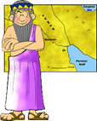
King Hammurabi’s Laws
Name:______________
Block:______

“Anu (a King)and Bel (a God), two called by name me, Hammurabi, the exalted prince, who feared God, to bring about the rule of righteousness in the land, to destroy the wicked and the evil-doers; so that the strong should not harm the weak; so that I should rule over the black-headed people like Shamash, and enlighten the land, to further the well-being of mankind.”
-Hammurabi

These are the words from King Hammurabi’s Prologue to his Laws; he believed he was the chosen one to “do right” for the people of Mesopotamia. He believed his Laws brought order, and fairness; the question is….do you?

Working in pairs, you are going to read the following situations that Hammurabi was faced with. Then you are going to decide as a group, what YOU think would be a fair way, or law to deal with the problem back then. We will then meet back together as a class, discuss all of the group’s solutions/laws, and look to see what Hammurabi did for those situations.

Situations:
What happens if a man is unable to pay his debts?
________________________________________________________________________________________________________________________________________________________________________________________________________________________________________________________________________________________

What should be done about a wife who ignores her duties and belittles her husband?
________________________________________________________________________________________________________________________________________________________________________________________________________________________________________________________________________________________

What should happen to a boy who slaps his father?
________________________________________________________________________________________________________________________________________________________________________________________________________________________________________________________________________________________

How is the truth determined when one man brings an accusation against another?
________________________________________________________________________________________________________________________________________________________________________________________________________________________________________________________________________________________

What should happen if a person saw a house burning down, and originally showed up to help put the flames out, but ended up stealing items from the house? ________________________________________________________________________________________________________________________________________________________________________________________________________________________________________________________________________________________

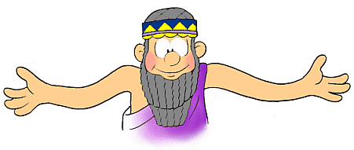

Go to the following websites to find out more about Hammurabi and his beliefs and codes:
http://mesopotamia.mrdonn.org/
http://www.socialstudiesforkids.com/articles/worldhistory/hammurabikingandcode.htm
http://www.kidspast.com/world-history/0038-hammurabi-babylonian-empire.php
Now that you have researched Hammurabi, consider what life was like for Mesopotamians before he ruled, like what you saw in the video last class. Below is a list of pros and cons that I have started for you, and you need to complete so you can answer the following question:
Do you think Hammurabi brought on fairness and justice to the Mesopotamians, or, do you think he simply brought on more fear for them to live in?
How does his code compare to Canadian laws?

Pros Cons
- Order was brought to Babylon *People lived in fear
- Citizens loved him *People of higher social class were
- Laws helped structure society treated differently
- *
- *
- *

