Use it or lose it
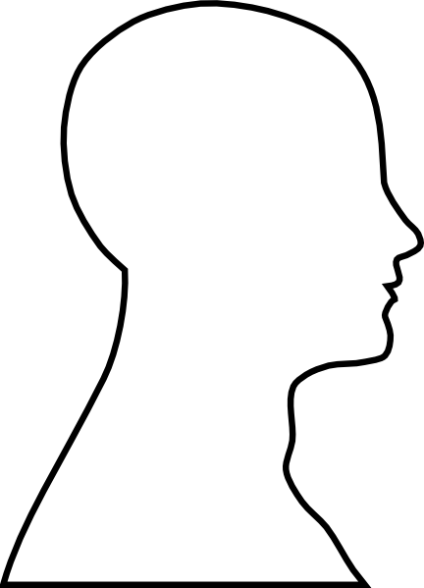
Draw a picture of what you think your brain looks like. List anything that you already know about the brain.

Name: _______________________ Date: _______________

